Mutants Revealed Duration: 3-4 days

The “Mutants Revealed” Project  The goal of Mutants Revealed is to unmask the mysteries behind superheroes' and supervillans' powers. Are their abilities real or a scientific hoax?  Scope of Work  Every team of two (2) students will investigate the physics behind the so-called mutation or scientific explanation. They will report their findings to the class and state their professional opinion regarding the "super"-powers in question and possible secret identities of this Super Workforce.  Deliverables  Superhero or Supervillan  Superpowers Explained  Secret Identity  Partner or Nemesis History  Individual Digital Portfolio  Mutant Revealed Presentation  Physics Overview  Sky High Challenge | 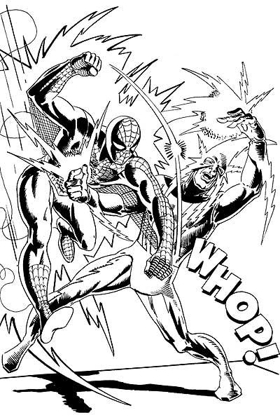
Requirements
The Superhero or Supervillan must:
-- Cover the assigned Physics Concept
-- Be from the List of Marvel Characters or an approved alternative (Original Character)
-- http://en.wikipedia.org/wiki/List_of_Marvel_Comics_characters

The Superpowers Explained must:
-- Discuss in detail how the Physics Concept is manipulated or defied
-- Have the important applicable equations, labeled variables, and example units
-- Describe a possible weakness

The Secret Identity must:
-- Be a profession that uses or is effected by the Physics Concept
-- Include an explanation regarding how the Physics Concept is used in the profession
-- Note: The profession can be different than described in the comic universe

The Partner or Nemesis History must:
-- Explain how their Physics Concepts make them either perfect partners or enemies
-- Have a brief explanation of how and why they became partners or enemies

The Digital Portfolio must:
-- Include an image of the Superhero or Supervillan (Heromachine)
-- http://www.ugo.com/channels/comics/heroMachine2/heromachine2.asp
-- Introduce the Superhero/Supervillan
-- Include the Partner or Nemesis History
-- Include the Superpowers Explained
-- Include a possible Secret Identity
-- Have a reflection covering "what went well, what could you do better, & what did you learn about yourself" in regards to the project itself AND the partnership
The Mutant Revealed Presentation must:
-- Be driven by the individual Digital Portfolio
-- Introduce the Superhero/Supervillan
-- Include the Partner or Nemesis History
-- Include the Superpowers Explained
-- Include a possible Secret Identity

The Physics Overview must be completed during the Mutant Revealed Presentations.

The Sky High Challenge will test the investigators abilities to identify other mutants during the movie.

Grading Criteria
The students will be working in teams of two (2), but they will each receive an individual grade. The varying weights for the following criteria will determine their overall score.
-- Thoughtfulness & Thoroughness
-- Work Ethic & Behavior
-- Deadlines & Deliverables
-- Exceeding Expectations
Additional Info
The following is a table of the Physics Concepts to be assigned to each team of two (2).

PHYSICS CONCEPTS
Sound: Constructive & Destructive Interference
Impulse & Momentum
Motion & Wave Speed
Centripetal Force & Law of Universal Gravitation
Newton's 2nd Law: Statics & Dynamics
Potential & Kinetic Energy
Heat Energy and First Law of Thermodynamics
Current & Ohm's Law
Work by a Heat Engine & Entropy
Light: Concave & Convex Lenses
Work & Torque
Hooke's Law & Spring Energy
Angular Velocity & Tangential Velocity
Induction & Friction

